PERSONAL

CAREER DEVELOPMENT PLAN



You are here for a successful career!

Remember, the hardest step to take is the first one. This Personal Career Development Plan template will help you to achieve your personal and professional goals by organizing your thoughts and putting them into an “action plan” format you can follow.



The future depends upon what you do today

**SIX STAGES OF THE CAREER DEVELOPMENT CYCLE**

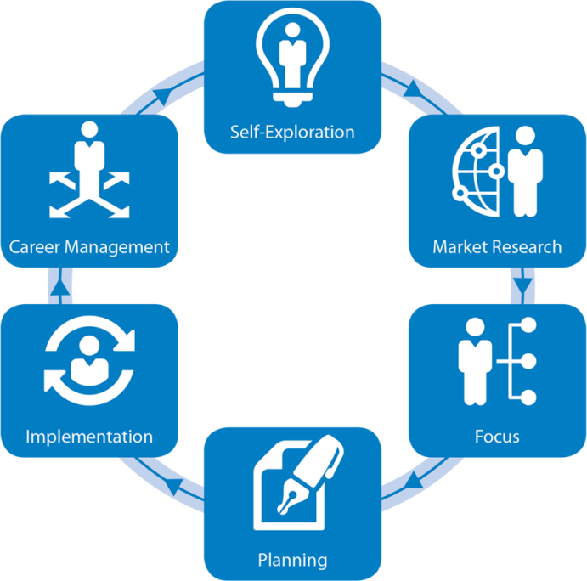

1. **Self-Exploration** is an opportunity to reflect on your skills, interests, passions, values and whether/how you’ve integrated these into your past assignments in School/College or organization.
2. **Market Research** involves investigating sector, industries, companies and functional areas of interest.
3. **Focus** is the intersection of the first two stages, overlapping your interests with what is happening in the market and setting a goal for yourself.
4. **Planning** is creating your marketing materials (like resume, social media profiles, cover letter and interview responses etc. to reflect your personal brand.
5. **Implementation** is the launch of your plan during which you venture out in campus placements, career fairs, networking activities, and job interviews etc.
6. **Career Management** covers the transition into your new role as well as periodic evaluations of your career and the flow back into the next iteration of the job cycle.

This Personal Career Development Plan document focuses on first four stages of the process to get started. Data & information generated will later be used to develop key marketing materials.

**STEP-1: SELF EXPLORATION**

(Knowing Yourself)

Self-Exploration is an opportunity to reflect on your skills, interests, passions, values and whether/how you’ve integrated these into your past assignments in School & College etc. This first step in planning your career involves evaluating and understanding your aspirations; strengths; interests; values and personal influences. You must also use the self assessment done through psychometric testing.

Complete a self-assessment and record your strengths, interests, and competencies.

**My Strengths:** I have the capacity to solve instance problem up to some point of limit. I can adapt myself in a team whatever it maybe. I am much aware of cyber threads. So, I can safeguard myself in the technological modern world. I am also able to participate in various events to gain exposure. I can improve my knowledge of my own. I will be more punctual in time management. I will be a great leader in team management.

**My Skills and Competencies**:­­­­­­­­­­­­­­­­­­­­­­­­­­­­­­­­­­­­­­­­­­­­­­­­­­­­­­­­­­­­­­­ I have more knowledge in coding language like C, Java etc..., I can handle security tools like Metasploit, Nmap and other tools related to analytics and data management. I have able to learn quickly if I interested in the work. I can handle different type of situation and make solution for that situation. I already coordinated more fun full events like Mr and Ms detective. I attended more workshops related to cyber security.

**My Interests:** I’m interested in travelling. I will try to find to work related to travelling. But I m a computer science student. I will make job to be as an analyst for various companies simultaneously. So, I have the possibility to make travel by the company to various location all over the world and I can also improve my knowledge through company experience.

­

**My Values:** My friends told me that I am very honest and trustworthy person. But I’m punctual in all my work and responsibilities. Basically, I won’t take any work if I take that work. I will complete it under with my satisfaction. I try to be in perfect but in some point, we are not suppose to do that in perfection.

Discuss your skills and strengths with friends, faculty mentor or any industry mentor to gain a better understanding of all the personal factors that influence your career options and write down additional information that may be important.

Mostly I will ask my friends and teacher to give some feedback about me and my behavior to enhance myself. Then only I am able to rectify my mistake and I will try to change or avoid that type of mistakes. Mostly they told me that I have to increase my communication with people in the outer world and suggested me that don’t be in comfort zone. So, I came to LPU to get some exposure and to communicate and connect with different kinds of people and try to know their behavior and culture with their lifestyle of different states in India and also I meet some other foreigners and communicate with them then made new connection with them. At first, I know my native language only. After I came to LPU, I tried to learn Hindi as new language and I am also very eager to learn some other languages and I am daily getting new types of experience with unknown people and enjoying every day with some new things. I am also getting about new types of food which I had ever tasted. But as of now, I never visited library in my precious course but now I am getting new information from library, and I try to make use of the library in a very successful way. At the beginning, I am not aware of any sectors like finance, marketing and supply chain, but I am daily getting new learning in those sectors that are very much interesting and also It will be so helpful in my career in future. The main thing is I am daily updating myself from Newspaper. I am good at computer science with coding and handling data. So, I try to focus my career in finance and business analytics. It might be helpful for me to increase my knowledge in data management field. Basically, I am here to gain more knowledge in management field. But I don’t know where to start those in this field in MBA. I am improving my knowledge in basics of finance, accounting and marketing. But I need small amount of time to adapt to this field. For me, this is more interesting because I am able to deal with real problems in real world.

____________________________________________________________________________

**ASSESSING PERSONALITY**

In addition to interests, values, and strengths, other aspects of your personality are also very important to consider in your career choices and planning. You may have an intuitive sense of who you are and with a little self-reflection or input from people close to you, you will be able to identify certain aspects of your personality that are important to consider with regard to your career trajectory.

Psychometric assessment undertaken in Pre-Term will be of a great help in this regard and must be used to assess your personality.

The list below contains words that describe various personality styles. As you read through the list, circle 10 of those items that best reflect aspects of your personality. Be honest and realistic in your choices. This is an inventory of who you actually are, not who you would like to be or how you would like others to perceive you.

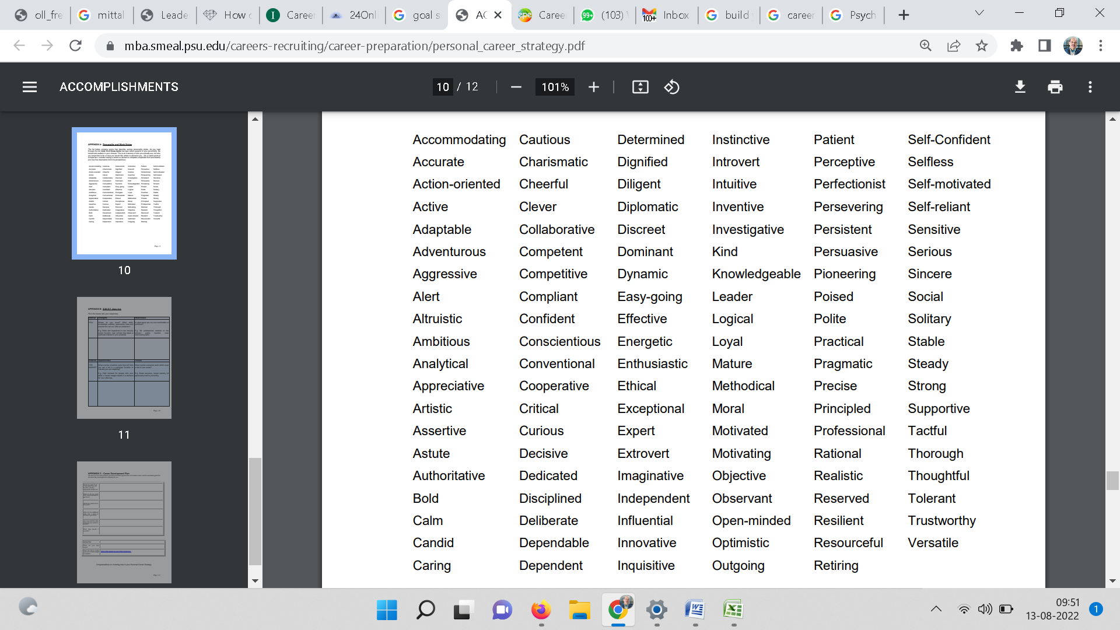

**CAREER HISTORY**

Objective: To identify your prior learning and critical experiences. Identify transferable skills to highlight in resume and interviews. Focus on past 3-5 years for this exercise and explore the rest on your own if applicable.

|  |  |  |  |  |
| --- | --- | --- | --- | --- |
| School/College or Company (If with work experience) | Position  Held | Achievements | Skills Used | Life Lessons Learned |
| Kongu Engineering College | Event coordinator | Conducted detective event in online mode | Time Management,  Decision making | Take right decision in right point of time. |
| Coding event | Top 20 | Cash price with cerificate | Coding skill | Don’t get tired until achieve. |
|  |  |  |  |  |
|  |  |  |  |  |

What are the three most significant achievements in my career?

|  |  |  |
| --- | --- | --- |
| Event | Organizer (State, School, College, NGO etc. | Position/Significant Achievements |
| Paper presentation | College | 2nd price |
| Coding event | College | Top 20 |
|  |  |  |
|  |  |  |
|  |  |  |
|  |  |  |

**STEP-II: MARKET RESEARCH**

(Your Target)

Knowing where you want to go in your career makes planning the next steps much easier. Having a goal in mind also helps you identify and take advantage of opportunities at work that might take you closer to your career aim. Gather information about the career options in your field of interest/specialization. Look at job advertisements in your field in newspaper or LinkedIn or popular job portals like Naukri.com etc. and record the minimum and ideal job requirements.

Desired Industry Sectors to work in after MBA

|  |  |
| --- | --- |
| 1. Banking and securities | This sector can contain more set of data like transactions and accounts of the people. It will help me to providing data in large amount. Then I can improve knowledge in manipulating data. |
| 2. Retail and Wholesale trade | This sector will contain data of customer and their frequently purchasing product. Then I can predict what the customer will buy product on their next purchase. |
| 3. Healthcare Providers | This sector also contains data of patient and their prescriptions. I would like to provide my service to this sector to help patient with their health. |

Desired organizations for Internship

|  |  |
| --- | --- |
| 1. Amazon | If I complete my internship in the reputed company.I will get more recognition more than anyone else. I m eager to know how the company is working in providing product with data. |
| 2.Iotech design | It is a startup kind of company. From this type of company, I will learn about business statistics and analyst kind of work and how the company is working in that fields. |
| 3.Integra Capital Management Limited | I will know to analyze the funds to provide clients high returns with low risk and work on financial stock advisory for clients |

Desired organization to work for after MBA

|  |  |
| --- | --- |
| 1. Mu Sigma | Mu Sigma is one of the most renowned decision sciences and business analytics organizations that assist businesses to boost intelligent decision-making through Mu Sigma’s best in class and accurate data analytics solutions. MuSigma is well known for providing solutions for various industries, specialized in-demand analytics, marketing analytics, network planning and optimization, and risk analytics among other services. |
| 2. Fractal Analytics | Fractal has created more than 40 specialized and niche services for applications in different industries such as hospitality, healthcare, retail, BFSI, and technology. Backed by sophisticated analytics, the company’s solutions assist in delivering smarter, faster, creative, and accurate decisions. |
| 3. Absolut Data | Absolut Data is upsetting the customary scientific methodology by following a diagnostic approach and combining innovation, complex information, and progressed analytics. Their image NAVIK has a line of amazing products for the advertising, sales, and examination experts, empowering them to harness the power of [artificial intelligence](https://www.analyticsinsight.net/must-know-latest-ai-acquisitions-of-july-and-august-in-2021/). |
| 4. Tiger Analytics | Tiger Analytics has been a trusted [data science](https://www.analyticsinsight.net/how-are-organizations-leveraging-ai-and-data-science-for-effective-pr-strategies/) and data engineering partner. They bring about a great deal of expertise in customer analytics, marketing science, and operations and planning analytics. |

Desired job titles/functional roles after MBA

|  |  |
| --- | --- |
| 1.Financial Analyst | I will work to improve the financial performance by analyzing forecasts, variance, trends in financial results and Create activities and policies that will help boost financial growth |
| 2.Business Analyst | I can analyze current business processes and devise improvement solutions and Identify areas for improvement and put technical solutions in place. |
| 3.Data Analyst | A data analyst collects, cleans, and interprets data sets to answer a question or solve a problem. They work in many industries, including business, finance, criminal justice, science, medicine, and government. |

**STEP-3: FOCUS**

(Gap Analysis)

The objective is to identify a functional role whose duties, tasks, role and responsibilities are a good “fit” with your interests, skills, knowledge and experience.

**SWOT Analysis**

A SWOT analysis reveals Strengths, Weaknesses, Opportunities and Threats in you and the employment market. It enables you to analyze the realism of your vision and plan accordingly. Additionally, it could help you specify goals and objectives to mitigate gaps (weakness and threats that separate you from where you would like to be) while also strategically leveraging personal strengths and market opportunities.

|  |  |  |
| --- | --- | --- |
| **YOU** | **Internal** | |
| **Strength**  *Where do you excel? What skills, knowledge, abilities, personality traits and experience can you offer an employer?*  I am more familiar with the analysing of data and also I am able to develop code according to my need in the analysing field.  I am having the ability of observing others.  I am able to adopt to anyone with good mind. | **Weakness**  *In what areas are you not comfortable or proficient?*  I am not aware of what type of things to do at first..  I try to adopt myself quickly.If I am not able to adapt quickly. I ll feel bad. |
| **MARKET** | **External** | |
| **Opportunities**  *What market situations exist that will help you get a job in a particular function or industry you are targeting?*  If the company need analytical skilled person with data interpretation and able to handle various type of analytical tools.Then I will be a good choice.  In recent years,Business analytics field is blooming. | **Threats**  *What market scenarios exist that pose a risk to your goals?*  If the company need average skilled guys to provide low package. Then It will make trouble for me.  Mostly there are few companies in hiring business analytics people. |

**STEP-4: PLANNING**

(Plan to fill the gaps)

Now fill in the boxes below with 3 job descriptions of functional roles you identified in STEP-3 above. For each of the role, identify the skills companies are looking for and

Functional Role-I : Business Analyst

|  |
| --- |
| What they want?  For this job, Company need good decision making people. |
| What I have  I have minimum level of making decision. |
| What are the gaps, and how might they be addressed?  I need more practice to familaiar in making decision. Main thing, I have to read more case study related to decision making. |

Functional Role-II : Data Analyst

|  |
| --- |
| What they want?  Company want the employee should familiar with handling data. |
| What I have  I am able to handle data with various analysing tools. |
| What are the gaps, and how might they be addressed?  I have improve data handling style and have to improve speed of analysing. |

Functional Role-III : Financial Analyst

|  |
| --- |
| What they want?  The person should have to manipulate available data and make that which company we have to invest to gain more profit |
| What I have  I have manipulation skill by handling data. |
| What are the gaps, and how might they be addressed?  I need to pursue financial decision part. |

**MAKING CHOICES**

Consider the suitability of each option and decide (with the help of faculty mentor) which one is the best match to your aspirations and career goals.

The above 3 functional role are interconnected with each one. So each of the jobs are best as per my knowledge . I am preferring financial analyst.

Based on the choices you have made, and the development opportunities you have identified now write your goal(s) for the short and medium term. Aim to make each goal as specific as you can.

Goal 1:

Short term: To get a job related to financial analyst in high paying company for freshers. Mostly those are high paying job after few years.

Medium term: To analyse how the company is working in that field.

Write down what you need to do to achieve this career goal:

I have to improve in finance part to make good financial decisions which was related to my analyst part.If those 2 part combined together then I am able to be a good financial analyst.

Goal 2:

Short term: I have to improve my both business and financial analysis for making good decision.

Medium term: After improve my skills. I have to implement of those skills to maintain my financial status after few years.

Write down what you need to do to achieve this career goal:

Continuously, Observation of the financial market and stock market, the main thing is company,s recent and previous annual report.

**MAKE IT HAPPEN**

To achieve your goals, you need to have a course of action. You (and your advisor/mentor) need to have a clear understanding of what steps you will be taking, the commitment required by you and relevant time frames.

**Agreed course of action/action plan**

|  |  |  |  |  |
| --- | --- | --- | --- | --- |
| **Start Date** | **Completion Date** | **Skill, experience, knowledge to be gained** | **How will this be gained?** | **Provider** |
| 2018 | March 2022 | Coding language, 3 years of experience in coding and handling various tools for maintain and manipulating data in large amount. | Knowledge given by my previous degree. | College staff. |
| 2019 | 2022  No specific time  On Progress | Knowledge of handling automated tools | Though online | Self study |
| Jun 2019 | 2022  No specific time  On Progress | Aware of cyber threats | Workshops | Staff and self study |

No specific time indicates that there will no end for learning those knowledge or skill. Mostly, they will be partially achieve by self study.

**Proofs for above mentioned**

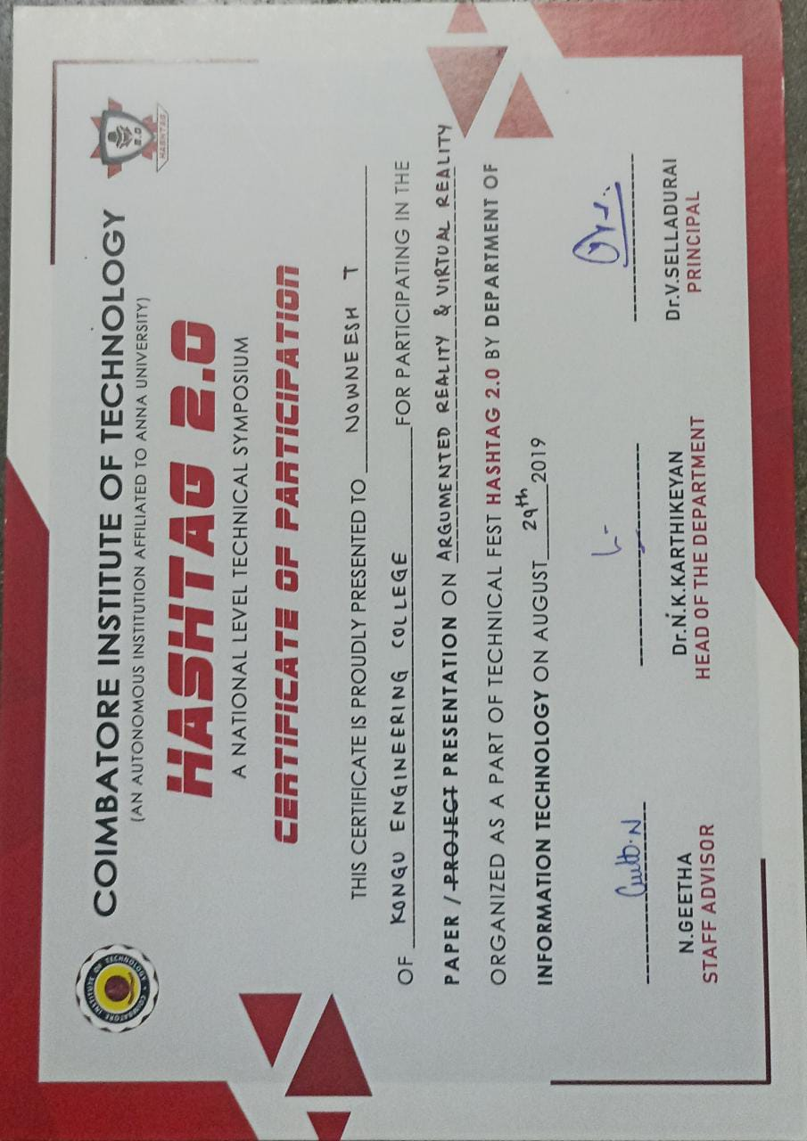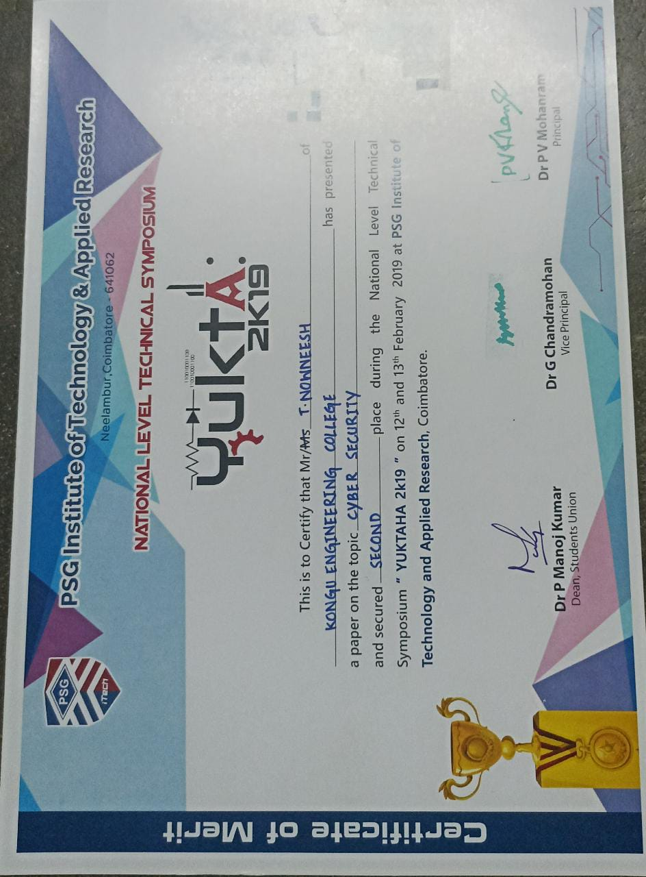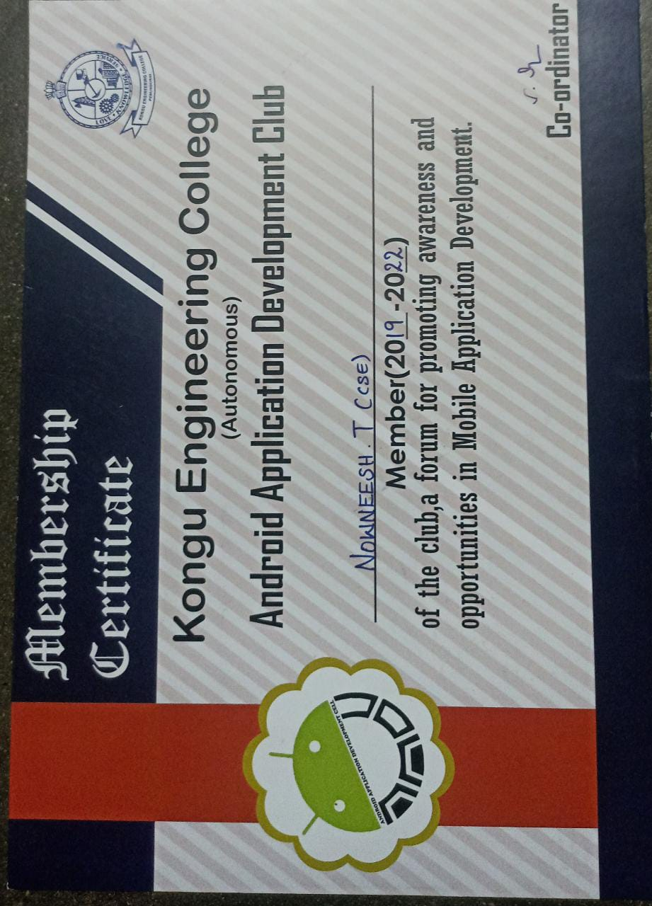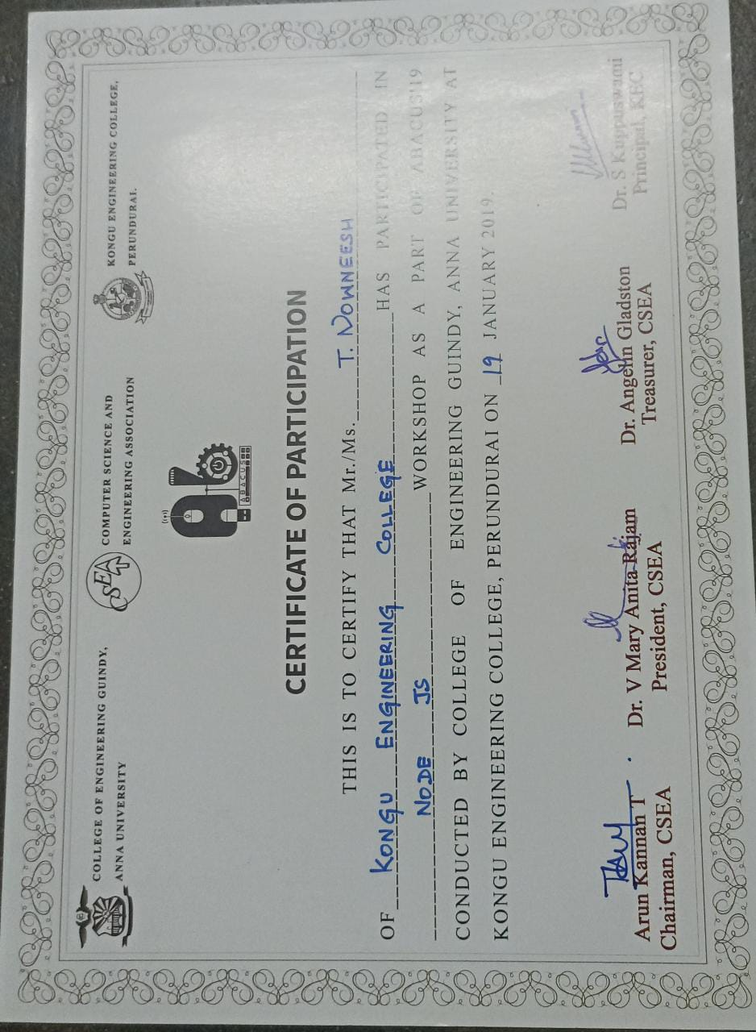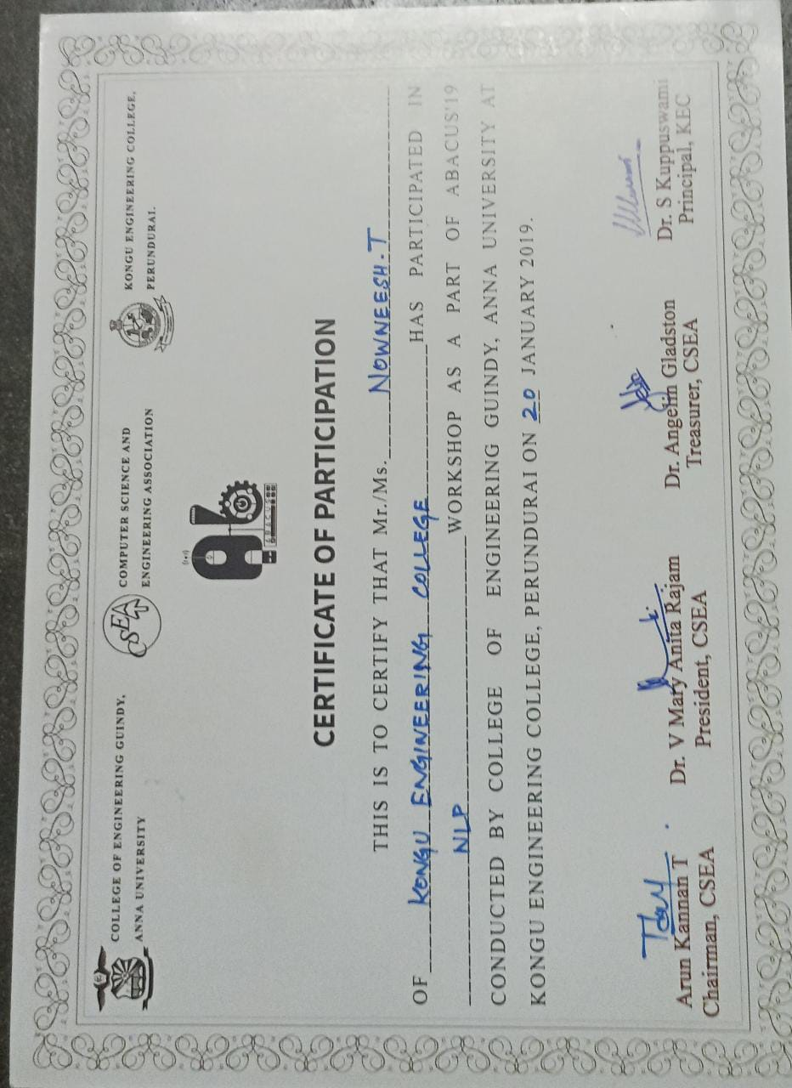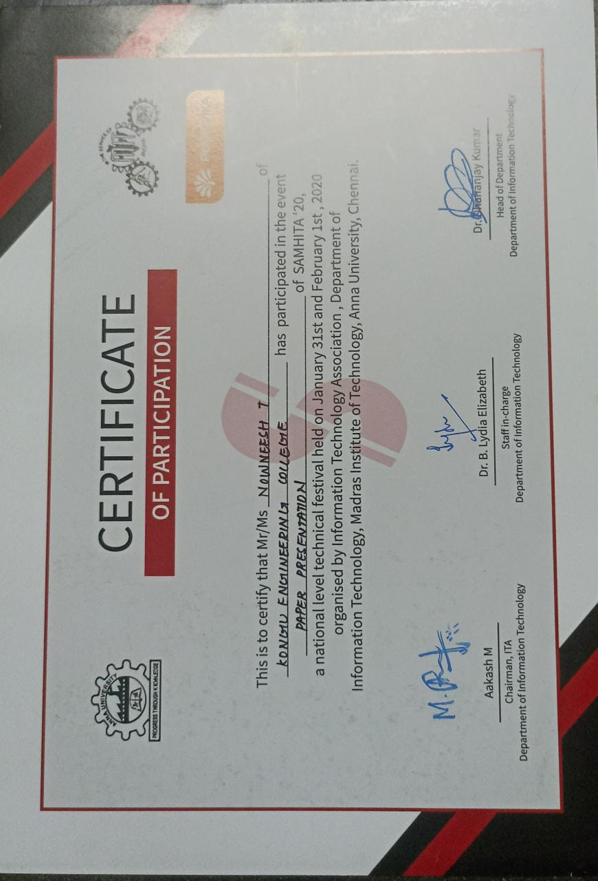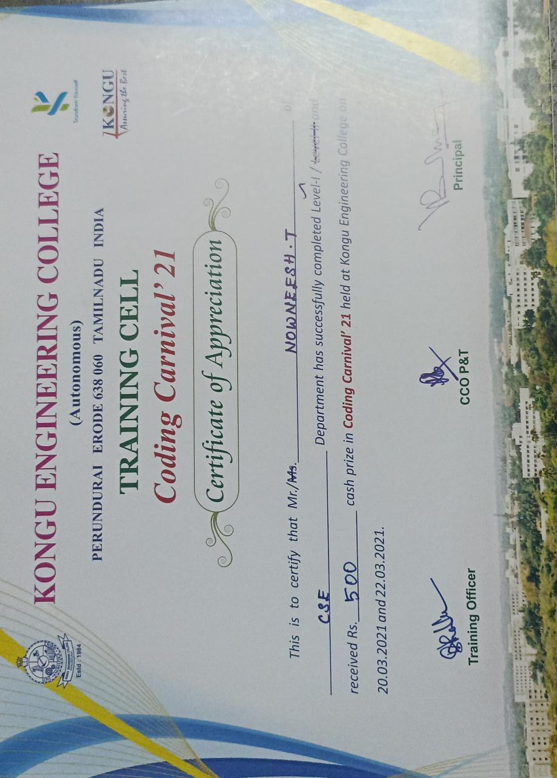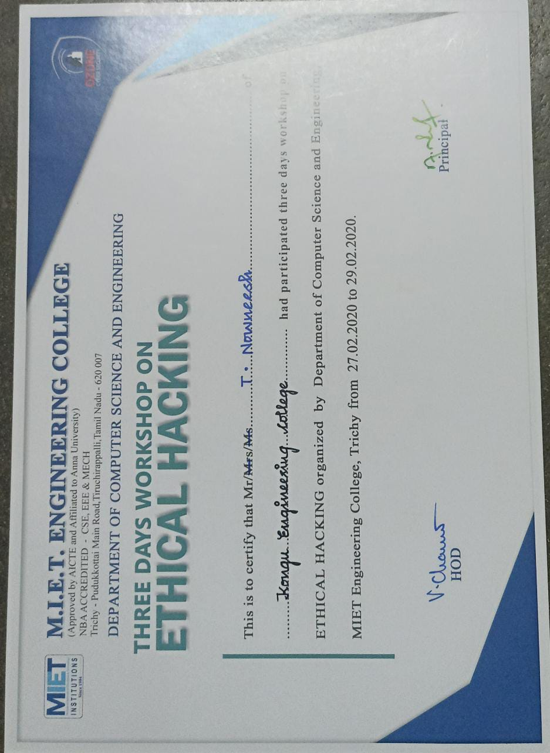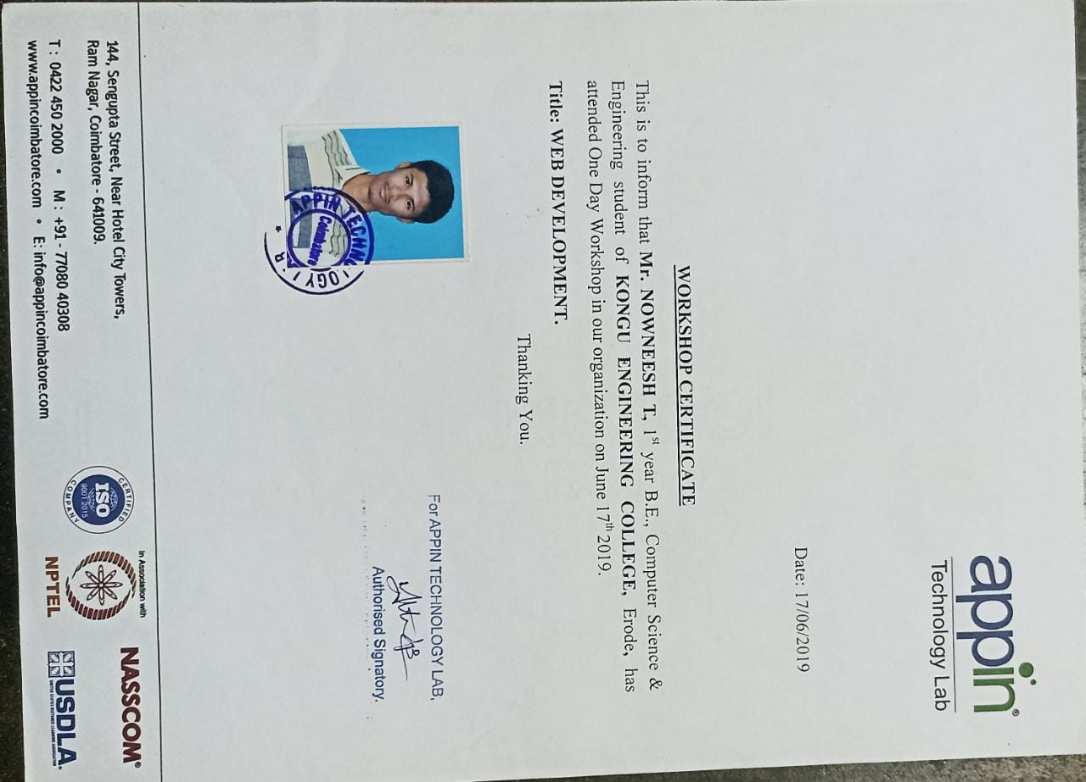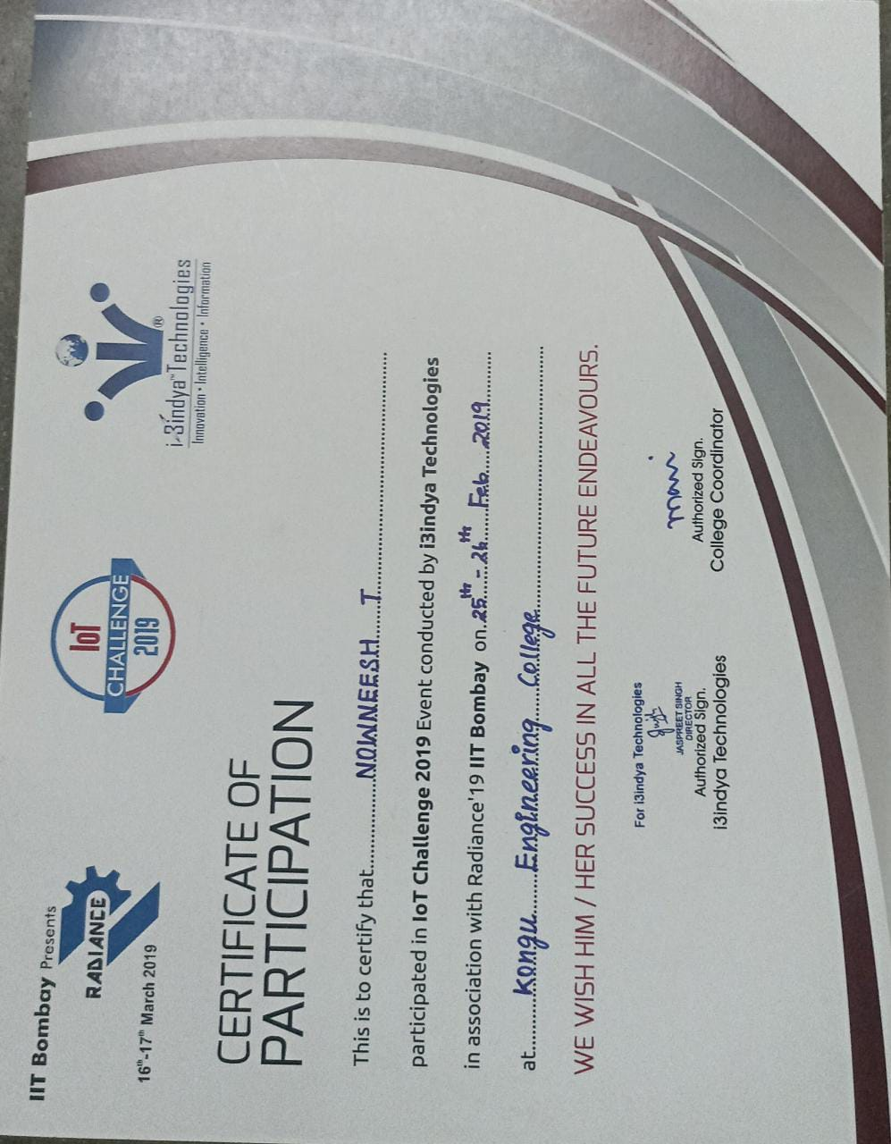

To work in an environment where I can utilize and sharpen my skills and be able to contribute to the progress of the organisation and the society at large.



**NOWNEESH**



**T**



Nowneesh123@gmail.com



+91



-



9965552513



**CAREER OBJECTIVE**

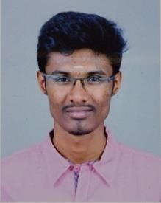

# ACADEMIC PROFILE

|  |  |  |  |
| --- | --- | --- | --- |
| **Degree** | **Board/University** | **Name of the Institution** | **Percentage \CGPA** |
| B.E.( CSE) | Anna University,  Chennai .(2018-2022) | Kongu Engineering College, Perundurai . | **8.5\*** |
| HSC | State Board (20162018) | Kongu Vellalar matric higher secondary school,chennimalai. | **87.5** |
| SSLC | State Board  (2015-2016) | Kongu Vellalar matric higher secondary school,chennimalai. | **92.2** |

# AREAS OF INTEREST

* Penetration testing
* Financial and data analyst

# PAPER PRESENTED

* Presented a paper entitled “**Cyber security in IOT**” in “SAMHITA ‘20” held on 31st January at **Madras Institute of Technology, Anna University, Chennai.**
* Presented a paper entitled “**Cyber security**” in “YUKTA ‘2019” at **PSG Itech,Coimbatore** and won 2nd prize**.**
* Presented a paper entitled “**Augmented Reality**” in **CIT Coimbatore.**

# PROJECT

Developed an Android Application [**https://github.com/nowncreation/darkmode.git**](https://github.com/nown-creation/darkmode.git) This is my github link of my Android Application.

# SKILL SET

**Programming Skills:** C, Java, Python, C++, Sql

**Other Skills:** Basic knowledge in handling security and automation tools.

# MEMBERSHIP LABEL

* Member in **Android Application Development Club** during the academic year of 2019-2020.
* Member in **Computer Society of India** during the academic year of 2019-2021.
* Event coordinator in **Android Application Development Club** during the academic year of 2020-2021.
* Executive member in **Indian Innovation Council** during the academic year of 2020-

2021.

# WORKSHOP ATTENDED

* Participated in **“IoT Challenge 2019”** conducted by i3indya Technology in association with Radiance’19 IIT Bombay held on 25th and 26th February 2019 at Kongu Engineering College, Erode.
* Participated in “**Ethical hacking workshop**” conducted by kyriyon technology at IIT research park.
* Participated in “**Ethical hacking workshop**” conducted by ozone cyber academy.

# PERSONAL PROFILE

Father’s Name : A.Thirumoorthy

Mother’s name : T.Kousalya

Date of Birth : 17.08.2000

Languages known : English, Tamil

Contact address : 218/A, Bharathi nagar, Ingur road,

Chennimalai.

Erode - 638051

Hobbies : Playing Badminton and Listening to Music

**DECLARATION:**

I hereby declare that the above information provided are true and best of my knowledge.

PLACE: Punjab **(NOWNEESH T)**  DATE : 30-09-2022

Congratulations on investing time in your Personal Career Development Plan



Build a plan but know the

REAL RESULTS

Comes from taking the actions to

EXECUTE IT